FINAL REPORT
BY: SAANVI SINGH
250934

Explanation:
- Downloading all required libraries. mounting google drive to in order to save the requirements.txt file, loading the dataset.
- Signal Preprocessing-
EEG data is very noisy and needs to be preprocessed to make it M.L. suitable. We have applied bandpass filter, notch filter, removed bad channels, re-referenced and done ICA followed by removing the bad components. We have also extracted the epochs.
- Feature Extraction-
We have extracted features using Xdawn and not manually.
- Classifier-
We have used classical M.L. models L.D.A., S.V.M and S.V.M. with ensemble learning as well as EEGNet(a C.N.N.) for building our speller. EEGNet code is from the 2018 paper: Lawhern et al. (2018) — EEGNet: A Compact Convolutional Neural Network for EEG-based BCIs with slight modifications to suit our data structure. We have also used class weights to handle data imbalance. Additionally, we have also used early stopping as well as reduce learning rate on plateau as without them the model was learning unstably.
- Evaluation-
We have computed classification metrics-accuracy,f-1 score,precision and recall for each model. We have also printed their confusion matrices and calculated ITR-the primary metric.
- Saving models, plots, metrics and creating the requirements.txt file.

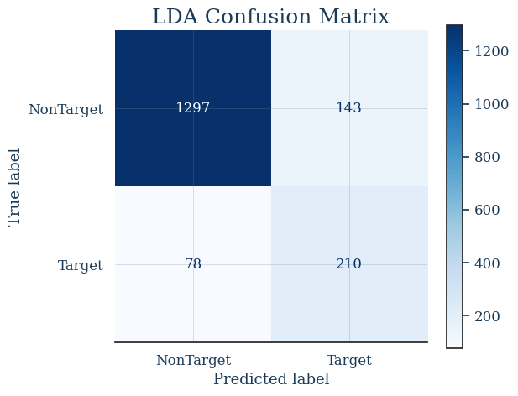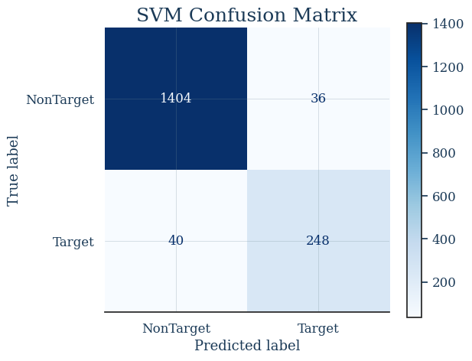
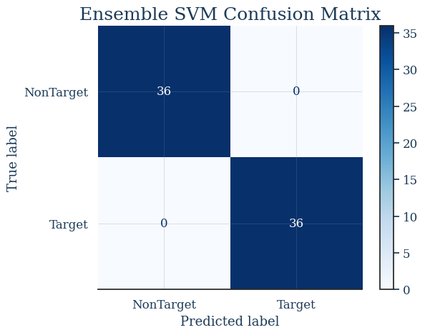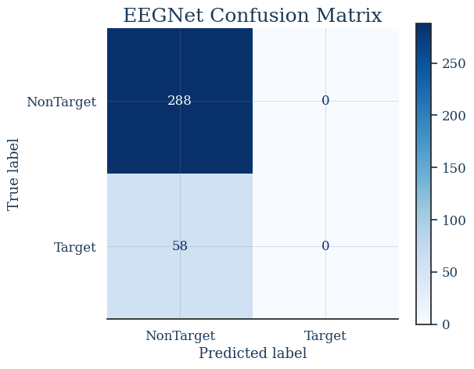

==================================================
==================================================
LDA Classification Report:
==================================================
precision recall f1-score support

NonTarget 0.94 0.90 0.92 1440
Target 0.59 0.73 0.66 288

accuracy 0.87 1728
macro avg 0.77 0.81 0.79 1728
weighted avg 0.89 0.87 0.88 1728

==================================================
SVM Classification Report:
==================================================
precision recall f1-score support

NonTarget 0.97 0.97 0.97 1440
Target 0.87 0.86 0.87 288

accuracy 0.96 1728
macro avg 0.92 0.92 0.92 1728
weighted avg 0.96 0.96 0.96 1728

==================================================
Ensemble SVM Classification Report:
==================================================
precision recall f1-score support

NonTarget 1.00 1.00 1.00 36
Target 1.00 1.00 1.00 36

accuracy 1.00 72
macro avg 1.00 1.00 1.00 72
weighted avg 1.00 1.00 1.00 72

==================================================
EEGNet Classification Report:
==================================================
precision recall f1-score support

NonTarget 0.83 1.00 0.91 288
Target 0.00 0.00 0.00 58

accuracy 0.83 346
macro avg 0.42 0.50 0.45 346
weighted avg 0.69 0.83 0.76 346
==================================================
FINAL EVALUATION RESULTS
==================================================
Model Accuracy ITR (bits/min)
---------------------------------------------------------------------------------
LDA 0.872 113.21
SVM 0.956 133.83
EEGNet 0.832 104.51
SVM + Ensemble 1.000 147.71
==================================================

In terms of accuracy, L.D.A. underperforms with .87 while S.V.M, with its R.B.F. kernel and balanced class weights overshines with .96. As expected, S.V.M. with ensemble learning shows a significant improvement with a whooping 1. However, we must take this perfect score with a pinch of salt as the testing is done only on 72 characters and reliable testing requires more samples. Nonetheless, S.V.M. with ensemble learning will indeed improve accuracy by reducing both bias and variance. EEGNet scores a low .84 and even that low .84 is misleading- target f1 is zero meaning EEGNet just predicts non target everytime. This is consistent with B.C.I. literature-classical M.L. models outperform EEGNet when the data set is small.
The primary metric, I.T.R., which rewards both accuracy and speed, is the actual yardstick for selecting the best model. S.V.M. + ensemble learning steals the show here, with 147.71 bits/min.

CONCLUSION
SVM+ Ensemble works best for our usecase.

